- 12 CE credit hours through AGD PACE
- Three nights at Miraval Arizona, plus breakfast, lunch and the welcome dinner
- $174 credit toward hotel amenities, and full use of the resort facilities
- Courtesy discount on up to two additional nights (before or after)

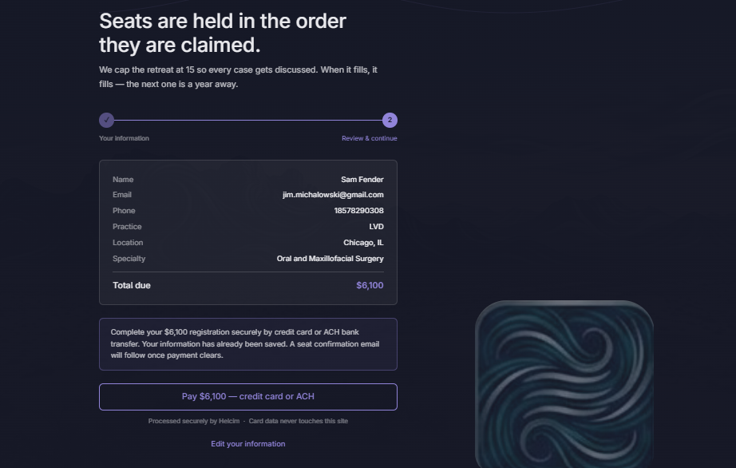

You had me put the file in the functions folder Dental Airways Retreat > Functions > helcim-init.js. Can i give you access to look at those folders because it sounds like we are going in circles?

C:\Users\jimmy\OneDrive\Documents\Claude\Websites\Dental Airways Retreat>type .gitignore
The system cannot find the file specified.

C:\Users\jimmy\OneDrive\Documents\Claude\Websites\Dental Airways Retreat>dir netlify /s
Volume in drive C is Windows-SSD
Volume Serial Number is F472-FD30
File Not Found

C:\Users\jimmy\OneDrive\Documents\Claude\Websites\Dental Airways Retreat>mkdir netlify

C:\Users\jimmy\OneDrive\Documents\Claude\Websites\Dental Airways Retreat>mkdir netlify\functions

C:\Users\jimmy\OneDrive\Documents\Claude\Websites\Dental Airways Retreat>

